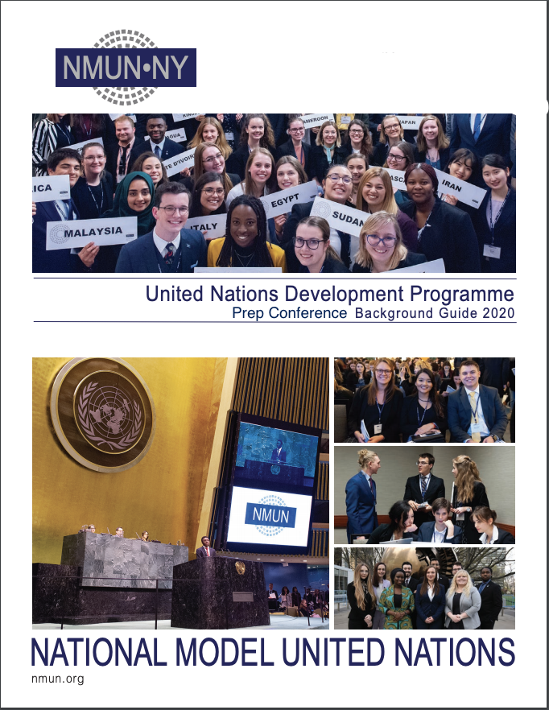
Committee Overview

The United Nations Development Programme (UNDP) embodies Article 55 of the Charter of the United Nations (1945), which outlines the organization’s responsibility to promote “higher standards of living, full employment, and conditions of economic and social progress and development,” as prerequisites to peace. Originally, development activities of the United Nations (UN) consisted largely of providing technical advice through the UN Expanded Programme of Technical Assistance (EPTA) and support for pre-investment projects through the UN Special Fund, created in 1949 and 1958 respectively, for the benefit of less developed countries. To streamline these assistance programs, General Assembly resolution 2029 (XX) of 22 November 1965 consolidated the EPTA and the UN Special Fund to establish UNDP as of 1 January 1966. Today, as the leader of the UN’s “global development network,” UNDP assists countries with achieving the Sustainable Development Goals (SDGs) and implementing the 2030 Agenda for Sustainable Development (2015).

Having broadened in scope, UNDP’s present mandate is “to empower lives and build resilient nations” for sustainable human development. As an assistance program, UNDP is “designed to support and supplement the national efforts of developing countries in solving the most important problems of their economic development, including industrial development.” Importantly, as emphasized by General Assembly resolution 59/250, national governments retain “primary responsibility” for development within their countries.

With a wide range of working areas including crisis prevention, democratic governance, environment, and human rights, UNDP can target the most important aspects for sustainable and equal human development with innovative strategies outlined in the 2018-2021 Strategic Plan. UNDP continues to work toward enhancing effective and inclusive democratic governance, strengthening resilience, eradicating poverty, and reducing inequalities and does so by working both bilaterally and multilaterally, tackling the SDGs to achieve their goals. UNDP continues to take the necessary measures to aid the international community in its goal of achieving the SDGs, remaining poised to play a significant role in promoting global development for a more sustainable future for all.

- Global Response to Natural Disasters
Introduction

Over the past 10 years, disasters have affected more than 1.5 billion people globally, and led to casualties, displacement, and large-scale economic, social, and environmental consequences. The cost of disasters has amounted to more than $1.3 trillion in recovery efforts worldwide over the past decade, including the rebuilding of infrastructure as well as the restoration of social services and local markets. The United Nations (UN) defines disaster risk reduction as the “concept and practice of reducing disaster risks through systematic efforts to analyze and reduce the casual factors of disasters.” The goal of disaster risk reduction is to decrease the destruction caused by events such as floods, droughts, hurricanes, earthquakes, and tsunamis through preventative practices. Disaster risk management is defined as “the systematic process of using administrative directives, organizations, and operational skills/capacities to implement strategies, policies and improved coping capacities; in order to lessen the adverse impacts of hazards, and the possibility of disaster.” The activities of disaster risk management are related to the prevention and mitigation of the negative impacts of hazards and resulting disasters, as well as increasing preparedness to effectively respond and recover from further hazards and disasters.

Disasters also present a threat to sustainable development as states which are trapped in an endless cycle of trying to respond to and recover from disasters are then unable to focus on sustainable development, particular those states with already limited infrastructure capacity.286 The 2015 Sendai Declaration and Framework for Disaster Risk Reduction 2015-2030 (Sendai Framework) represents the current UN framework document on disaster risk reduction. The goals of the Sendai Framework also recognize climate change as a driver of disaster risk and emphasize the importance of good governance for disaster risk reduction. In this context, the Sendai Framework calls for the creation and effective implementation of national and local disaster risk reduction plans by 2020. Additionally, it notes that by recognizing the economic consequences of disasters and planning response in advance, the impacts of disasters can be minimized or reduced.

International and Regional Framework

The first global framework document on disaster risk reduction was the Yokohama Strategy and Plan of Action for a Safer World, which was adopted by the World Conference on Disaster Risk Reduction in 1994 and set out the first disaster risk reduction principles, a plan action for disaster risk reduction, and follow-up guidelines. As a follow-up to the Yokohama Strategy, the World Conference on Disaster Risk Reduction adopted the Hyogo Framework for Action 2005-2015 (2005), which aimed to create a stronger and more detailed plans for disaster risk reduction that focuses on the role required by different partners, including local and national governments. In 2015, the World Conference on Disaster Risk Reduction officially adopted the Sendai Framework with its four priority action areas: comprehending disaster risk, improving disaster risk governance for disaster risk management, mobilizing financial resources for disaster risk reduction, and improving disaster preparedness.

In 2015, the General Assembly adopted the 2030 Agenda for Sustainable Development (2030 Agenda), which focuses on the economic, social and environmental dimensions of sustainable development and includes 17 Sustainable Development Goals (SDGs) to initiate action to promote sustainable development. Out of the 17 SDGs, SDG 1, 11 and 13 are particularly relevant to disaster risk reduction. For example, SDG 13 (climate action) aims to “[s]trengthen resilience and adaptive capacity to climate-related hazards and natural disasters [sic] in all countries.” Additionally, SDG 1 (no poverty) works to decrease vulnerable populations’ exposure to climate-related disasters along with the consequences of these disasters, while SDG 11 (sustainable cities and communities) targets a reduction of economic losses resulting from disasters.

The Paris Agreement (2015) aims to assist in disaster risk reduction efforts by mitigating the effects of climate change, which exacerbates coastal vulnerability, sea levels, atmospheric heat, and other phenomena, thereby increasing the quantity and impact of many types of natural disasters. The New Urban Agenda highlights the connection between sustainable urban development and disaster risk reduction, as it stipulates that Member States who “[a]dopt and implement disaster risk reduction and management” have more sustainable urban infrastructure, and therefore less loss of life due to disasters.

Role of the International System

The UN Office for Disaster Risk Reduction (UNDRR) is the main focal point for disaster risk reduction strategies and data within the UN Secretariat, and it is headed by the UN Special Representative of the Secretary-General for Disaster Risk Reduction. The General Assembly established UNDRR with its resolution 56/195 (2001) on the “International Strategy for Disaster Risk Reduction,” with its main objective being to better coordinate disaster risk reduction efforts of Member States. In 2017, the UNDRR updated the United Nations Plan of Action on Disaster Risk Reduction for Resilience (Plan of Action) to better align the Plan of Action with the Sendai Framework, the Paris Agreement, and the 2030 Agenda. The goal of the Plan of Action is to better coordinate the work of the wider UN system on disaster risk reduction.

Some examples of UN system wide efforts on disaster risk reduction include the work of the United Nations Entity for Gender Equality and the Empowerment of Women (UN-Women), the United Nations Educational, Scientific and Cultural Organization (UNESCO), and the United Nations Development Programme (UNDP). UN-Women promotes and facilitates the contribution of women to disaster risk reduction and the leadership of women therein. To this end, UN Women has proposed creating gender responsive disaster risk reduction sector briefs for different sectors to raise awareness of the role that gender plays in disaster risk mitigation and recovery. UNESCO focuses on capacity-building efforts for countries’ disaster risk management programs and collaborates with other UN agencies on this mandate. Recent efforts by UNESCO include setting up early warning systems, which help states expand their technological and scientific capacity to identify potential disaster then monitor and prepare for the potential disaster. Similarly, UNDP emphasizes disaster risk reduction by fostering risk-informed development and promoting cooperation and coherency of disaster risk plans among states as an important piece of disaster risk reduction. UNDP also works to provide information regarding risks and early warning system to states and presently has 64 programs focused on early warning systems.

UNESCO and UNDRR are part of the Global Alliance for Disaster Risk Reduction and Resilience in the Education Sector (GADRRRES), which aims to provide a comprehensive approach to safe school facilities, school disaster risk management, and risk reduction management. Civil society organizations (CSOs), in particular non-governmental organizations (NGOs), are also part of GADRRRES, such as the International Federation of Red Cross and Red Crescent Societies (IFRC), Plan International, and Save the Children. IFRC aims to reinforce disaster preparedness, promote the mitigation of the negative impacts of hazards, and protect development from disasters. Plan International, an NGO that aims to advance children’s rights, works to enhance disaster preparedness through education and school programs. Similarly, Save the Children, another NGO that focuses on children’s rights, centers their DRR efforts on children and provides guidelines for the protection of children in disasters.

While states themselves have the primary responsibility to reduce disasters, there is also a shared responsibility, especially when disasters have cross-border impacts. International cooperation helps states fill the gaps in their knowledge about disaster risk reduction. Some countries deal more frequently with disasters, most notably least developed countries (LDCs), small island developing states (SIDS), landlocked developing countries (LLDCs), archipelagic countries, and countries with extensive coastlines, due to their proximity to higher-risk geographic markers. Because of this, many states that are disaster-prone do not have the capacity to prepare, respond and recover from disasters therefore making international cooperation even more essential. The General Assembly has repeatedly encouraged international cooperation in disaster risk reduction to help mitigate the impact of Member States such as these who more impacted, as well as cross-border disasters. For instance, General Assembly resolution 73/231 (2018) mentions that developed states need to fulfill their commitments of official development assistance (ODA) regarding disaster risk reduction to have meaningful partnerships that are effective in reducing disaster risk.

In addition to the technical support, providing financial resources to help develop and implement disaster risk reduction strategies is another form of aid helpful to developing states, in particular LDCs, SIDS, LLDCs. Similarly, cooperation between the private and public sector also aids in disaster risk reduction. The private sector in particular can be a source of additional voluntary funding, which is important to disaster risk reduction in order to offset short falls in ODA. This highlights the important role the financing for development framework, in particular the Addis Ababa Action Agenda (2015), plays for achievement of the targets and priorities of the Sendai Framework.

Conclusion

Reducing disaster risk and meeting the targets and priorities of the Sendai Framework is important to ensuring the success of the SDGs. The Sendai Framework mandates the General Assembly to review the current progress in disaster risk reduction. Overall, there has been progress on disaster risk reduction since 2015; however current efforts are not on track to meet the 2030 targets. For instance, as per target (e) of the Sendai Framework, there are not enough local and national strategies in place, which inhibits the progress towards the remaining six targets of the Sendai Framework. Additionally, inclusive disaster risk reduction is crucial, as it ensures that vulnerable groups are part of the full disaster risk reduction process, however there remains significant work to be done to ensure fully inclusive processes. Finally, international cooperation and the mobilization of development finance, both from the public and the private sector, are also important tools for disaster risk reduction, demonstrating another key area of work for the international community to commit to, in order to ensure full success of disaster risk reduction frameworks.

Willett, Analeigh. “United Nations Development Programme Background Guide 2020.” National Model United Nations, 2019.

